

VILNIUS UNIVERSITY
ŠIAULIAI ACADEMY
BACHELOR PROGRAMME SOFTWARE ENGINEERING

Software Engineering
Investigation of Wikipedia's VCS

Student: Hanna Asiadouskaya

Lecturer: dr. Mykolas Okulič-Kazarinas

Šiauliai, 2024
Author of the current version of Higgs boson is Pbritti
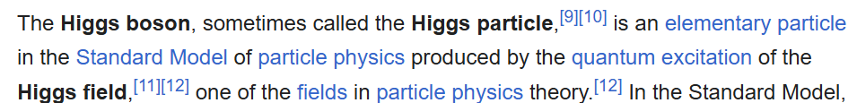
------------------------------------------------------------------------------------------------
First person to write current version is FT2
https://en.wikipedia.org/w/index.php?title=Higgs_boson&diff=next&oldid=1066165794
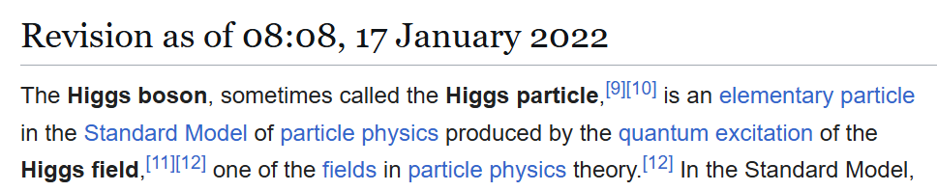
------------------------------------------------------------------------------------------------
First person to write current version but with different annotations is FT2
https://en.wikipedia.org/w/index.php?title=Higgs_boson&diff=next&oldid=1065343320
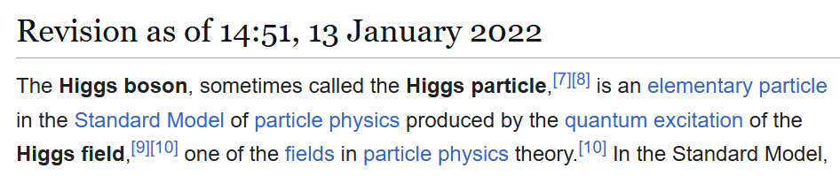
------------------------------------------------------------------------------------------------
First person to write previous version is RainGuest
https://en.wikipedia.org/w/index.php?title=Higgs_boson&diff=prev&oldid=881562964
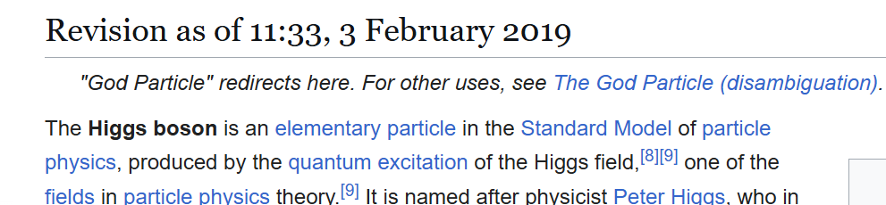
The author of the 20th word was FT2 with comment “top”
https://en.wikipedia.org/w/index.php?title=Higgs_boson&diff=next&oldid=1066165794

